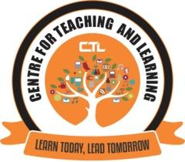

CENTRE FOR TEACHING AND LEARNING

REPORT ON Fundamentals of online learning engagement
Title: | Fundamentals of online learning engagement
Date and year: | 25/01/2021
Venue: | Online Webinar
Resource person/s: | RosemalizaMohd. Kamalludeen (Ph.D)
Organising Committee | Center for Teaching Learning
No. of Participants: | 22
Objective: | Fundamentals of Online learning Engagement
Summary of the proceedings: | Center for Teaching and Learning organised a webinar on “Fundamentals of Online learning engagement” for the faculty members. Rosemaliza Mohd. Kamalludeen (Ph.D), Assistant Professor, Department of Instructional Technology, Kulliyyah of Education, IIUM, Malaysia. Session was attended by 22 Faculties. Resource Person gave a brief description about how to engage online teaching. Various teaching tools were briefly introduced. She also spoke about how online assessment can be carried out and gave ideas and tips for smooth functioning of online learning.
Photographs:

Report Prepared by: Ms. Diksha N. Prabhu Khorjuvenkar

